Hanumesh Palla
AI Consultant | Generative AI & Cloud Architect
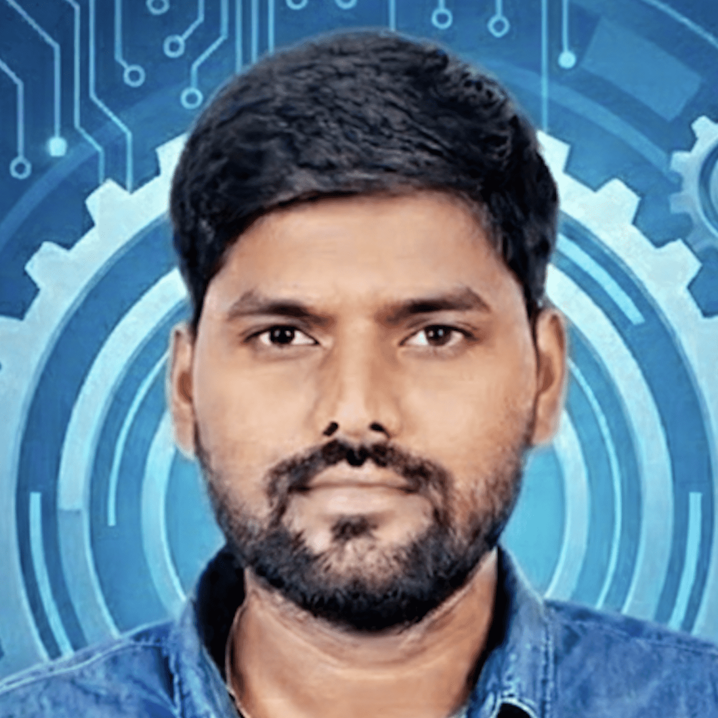 Bengaluru, India
hanumesh.palla59@gmail.com
+91 8867434647
LinkedIn: www.linkedin.com/in/hanus13
GitHub: github.com/hanumesh

Professional Summary
AI Consultant and AI Platform Architect with 13+ years of experience delivering enterprise-scale AI, Generative AI, and cloud-native platforms across healthcare, life sciences, and regulated industries. Strong expertise in Azure OpenAI, GenAI agents, LangChain/LangGraph, cloud architecture (Azure & GCP), microservices, and DevOps.
Proven track record in AI-driven modernization, including large-scale on‑prem to Azure migrations, AI agent platforms, FHIR/DICOM healthcare interoperability, and enterprise-grade CI/CD and IaC. Trusted advisor to leadership and engineering teams, translating business problems into secure, scalable AI solutions.

Core AI & Cloud Consulting Skills
Generative AI & AI Platforms
- Azure OpenAI, Generative AI solutions
- AI Agents & Orchestration (LangChain, LangGraph)
- Prompt engineering, Retrieval-Augmented Generation (RAG)
- AI governance, security, and enterprise adoption
Cloud & Architecture
- Microsoft Azure (primary), Google Cloud Platform
- Enterprise landing zones, VNET design, identity & security
- Multi-cloud and hybrid (on‑prem → Azure)
- Serverless, containerization, AKS
Healthcare & Data Interoperability
- FHIR, FHIR Store, DICOM
- Healthcare APIs & imaging platforms
- HIPAA-aligned architectures
DevOps & Automation
- CI/CD (Azure DevOps, GitHub, Jenkins)
- Infrastructure as Code (Terraform, ARM)
- Kubernetes, Docker
- Observability (Grafana, monitoring, log analytics)
Consulting & Leadership
- Architecture governance & roadmaps
- Stakeholder & executive communication
- Technical leadership & mentorship
- Agile / Scrum delivery

Professional Experience
AI Consultant / AI Platform Architect
Tata Consultancy Services (TCS)
Mar 2023 – Present | Bengaluru, India
- Designed and delivered enterprise AI and Generative AI platforms using Azure OpenAI to improve operational efficiency and healthcare innovation.
- Architected AI agents for healthcare workflows and data-driven automation.
- Led large-scale on‑prem to Azure migrations, improving scalability, reliability, and compliance.
- Defined AI reference architectures, reusable cloud patterns, and governance standards adopted across multiple programs.
- Partnered with business leaders and engineering teams to align AI strategy with business outcomes.

Cloud Architect / AI Solution Architect
CIGNA Corporate Services / Johnson & Johnson Services Inc
Nov 2022 – Feb 2026
- Led end‑to‑end migration of GE Healthcare’s on‑prem datacenters to Microsoft Azure, including 80+ TB of live data.
- Implemented cloud-native microservices on AKS, accelerating deployments and improving system resilience.
- Designed FHIR-based APIs and healthcare integrations across Azure and GCP.
- Built enterprise CI/CD and IaC pipelines (Terraform, ARM), reducing provisioning time and operational risk.
- Automated multiple Dynamics 365 (D365) modules, reducing deployment time by ~40%.

Technical Lead
Capgemini Engineering
Oct 2019 – Jan 2022
- Led teams delivering cloud, DevOps, and modernization initiatives.
- Worked with telecom clients on 5G, IoT, and cloud platforms.
- Established CI/CD best practices using Azure and GCP.

Senior Software Engineer
Siemens Healthineers
Jul 2017 – Oct 2019
- Migrated a DICOM-based monolithic healthcare system to microservices with CI/CD.
- Used AKS, ACI, ARM templates, and DevOps pipelines for scalable delivery.
- Improved deployment reliability and team velocity.

Earlier Experience
- Sr. Associate – Technology, Synechron (Morgan Stanley)
- Application Engineer, Raw Engineering
- Associate Software Developer, Tresbu Technologies

Key AI & Cloud Achievements
- Architected enterprise Generative AI solutions leveraging Azure OpenAI.
- Delivered large-scale healthcare cloud migrations with compliance and security.
- Designed AI-powered healthcare platforms using FHIR & DICOM.
- Established cloud governance and AI best practices across organizations.
- Reduced infrastructure provisioning and deployment times through automation.

Certifications & Awards
Certifications
- Generative AI Fundamentals (Academy Accreditation)
- DevOps Foundation (Internal)
- Domain Advisory – Foundation Curriculum
Awards
- TCS AI Idea Igniter (2025)
- TCS AI Spark (2025)
- Xcelerate Warrior Certificate (2025)
- Microsoft OpenHack Participation
- Cisco 50K Service Milestone

Education
Bachelor of Engineering (Electronics & Communication)
Visvesvaraya Technological University | 2008 – 2012

